Project MI Tracker:

Setup Process:

* Install Python version 3.6.5
  + Link to download the python version : <https://www.python.org/>
  + Select 64 or 32 bit on the basis of bit system has on which python is to be installed
  + While installing python, use customize option check/tick **‘Install for all User’** and **‘Add Python to Environment Variable’** options
* Install Atom (Editor):
  + Link to download Atom: <https://atom.io/>

Setup IIS for Django Project:

* Go to Control Panel:

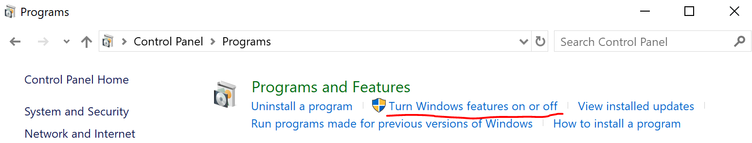

* Check CGI to enable it as highlighted below in screenshot
* 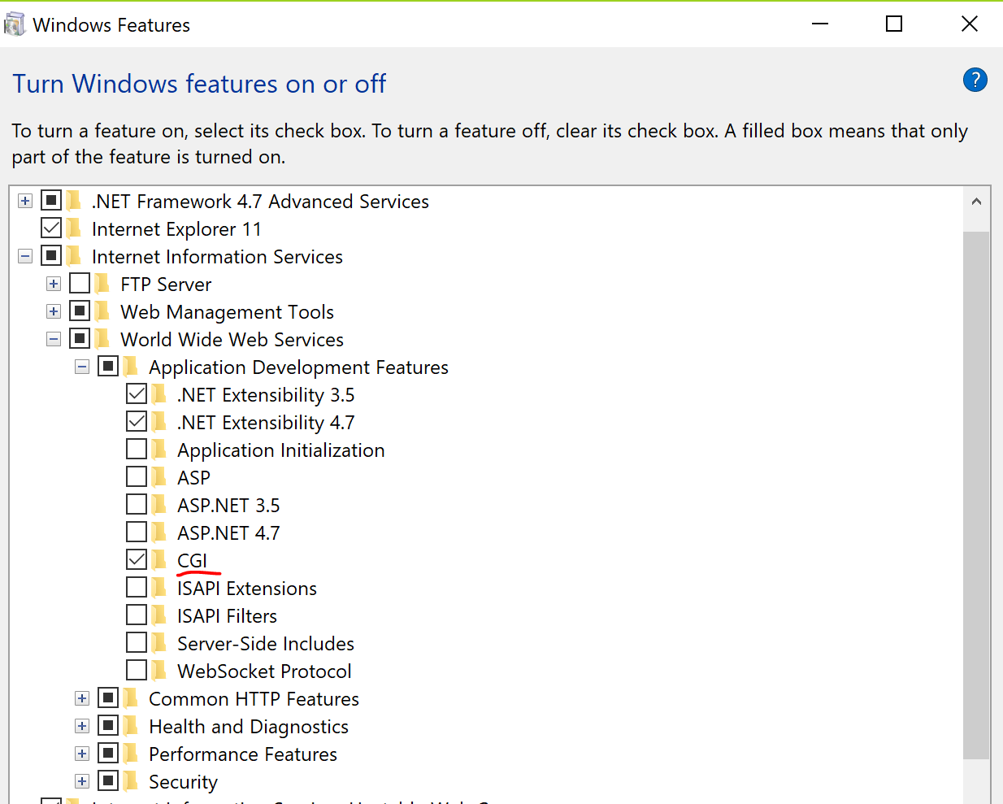
* Incase CGI is not installed than click next to install and Click Install.

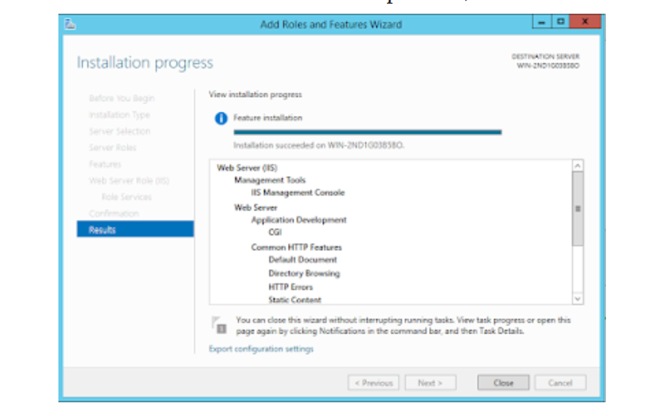

Configure FastCGI:

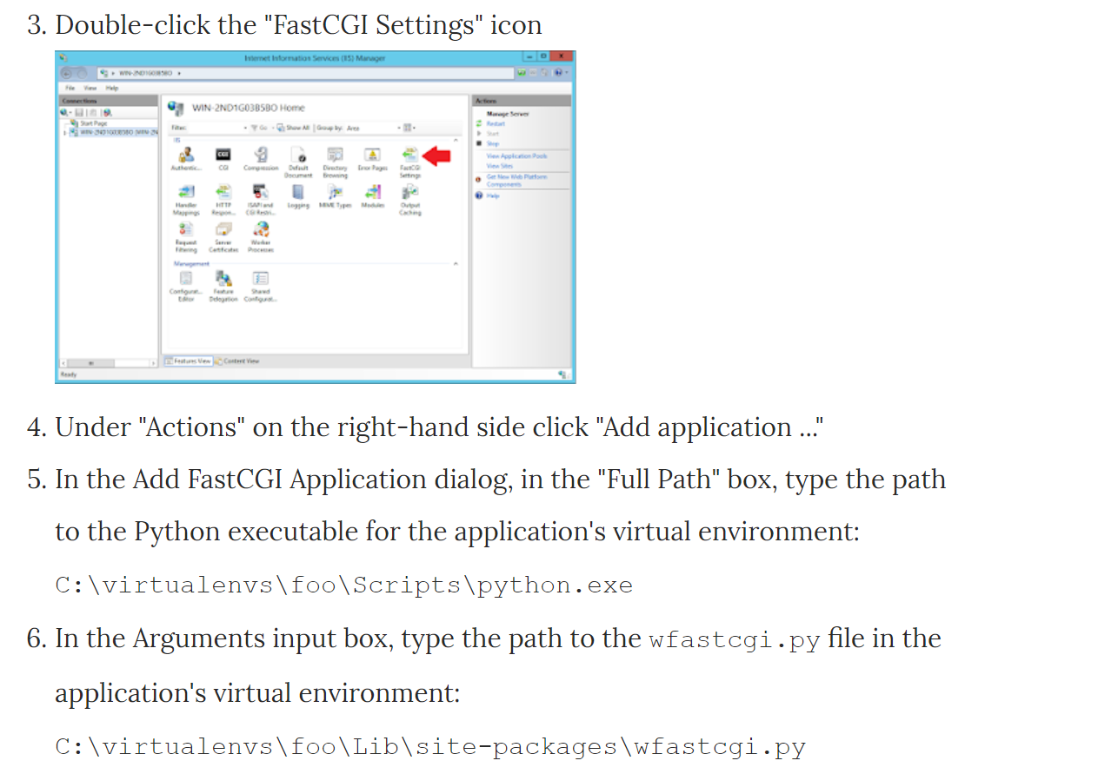

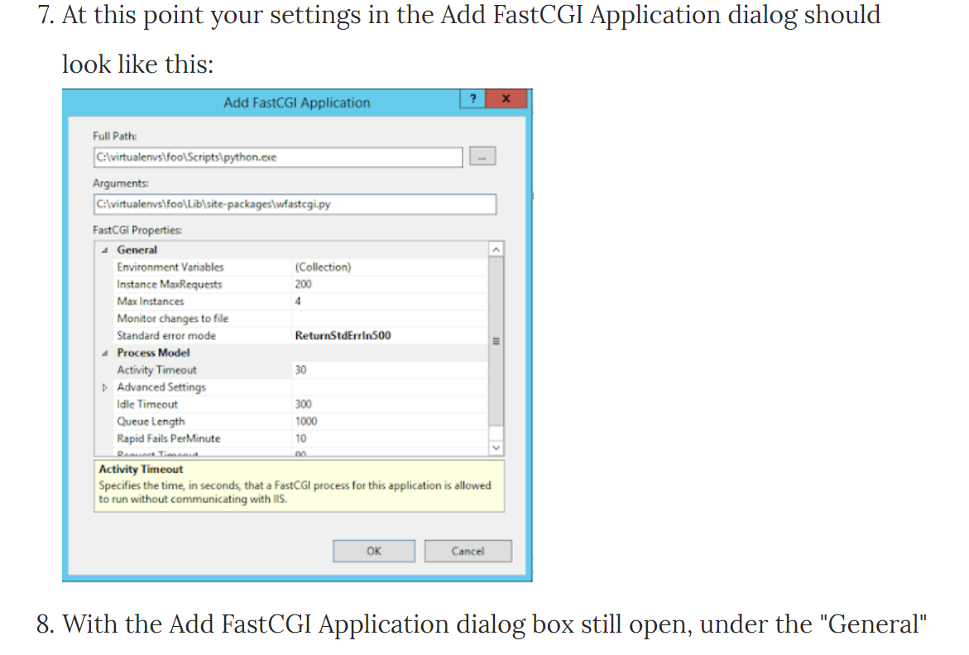

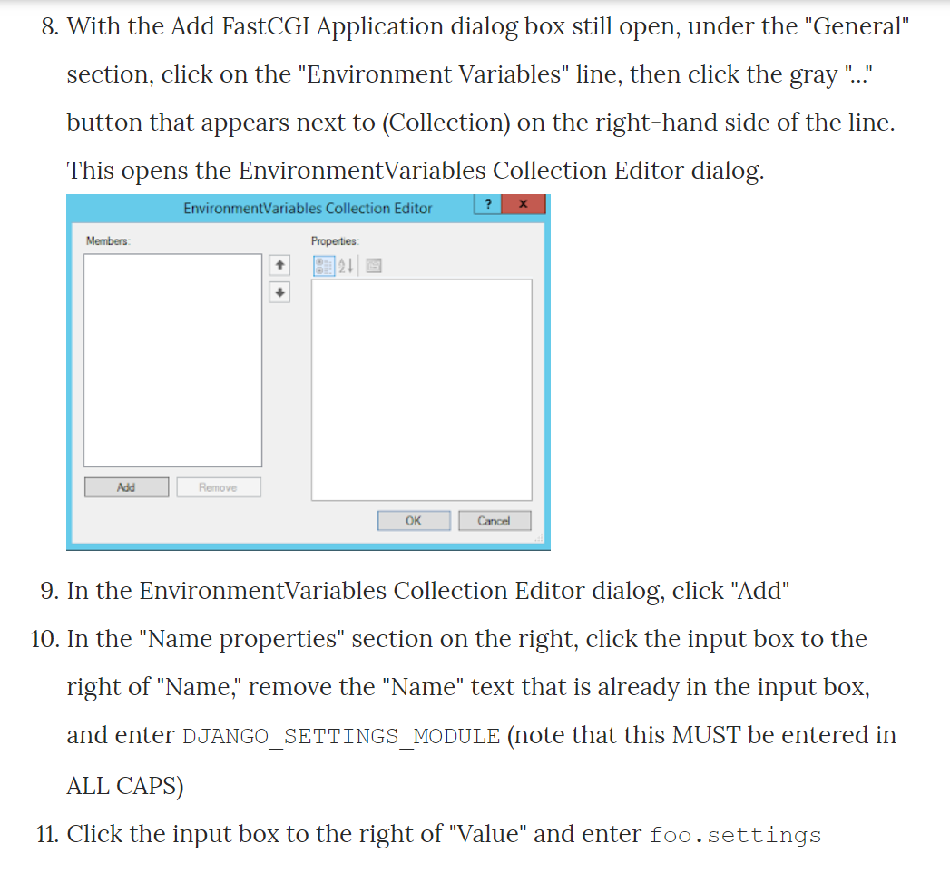

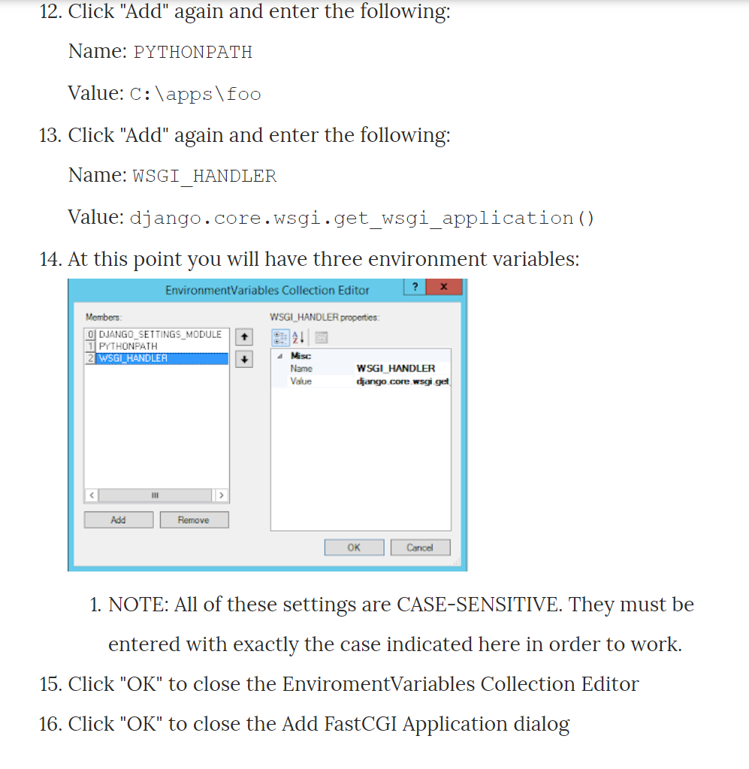

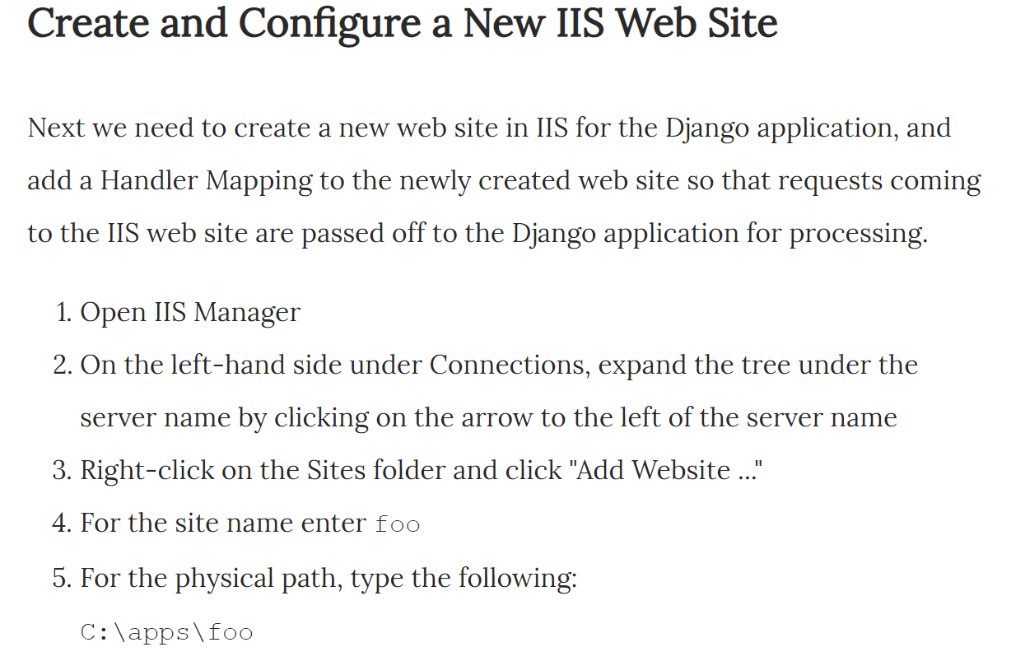

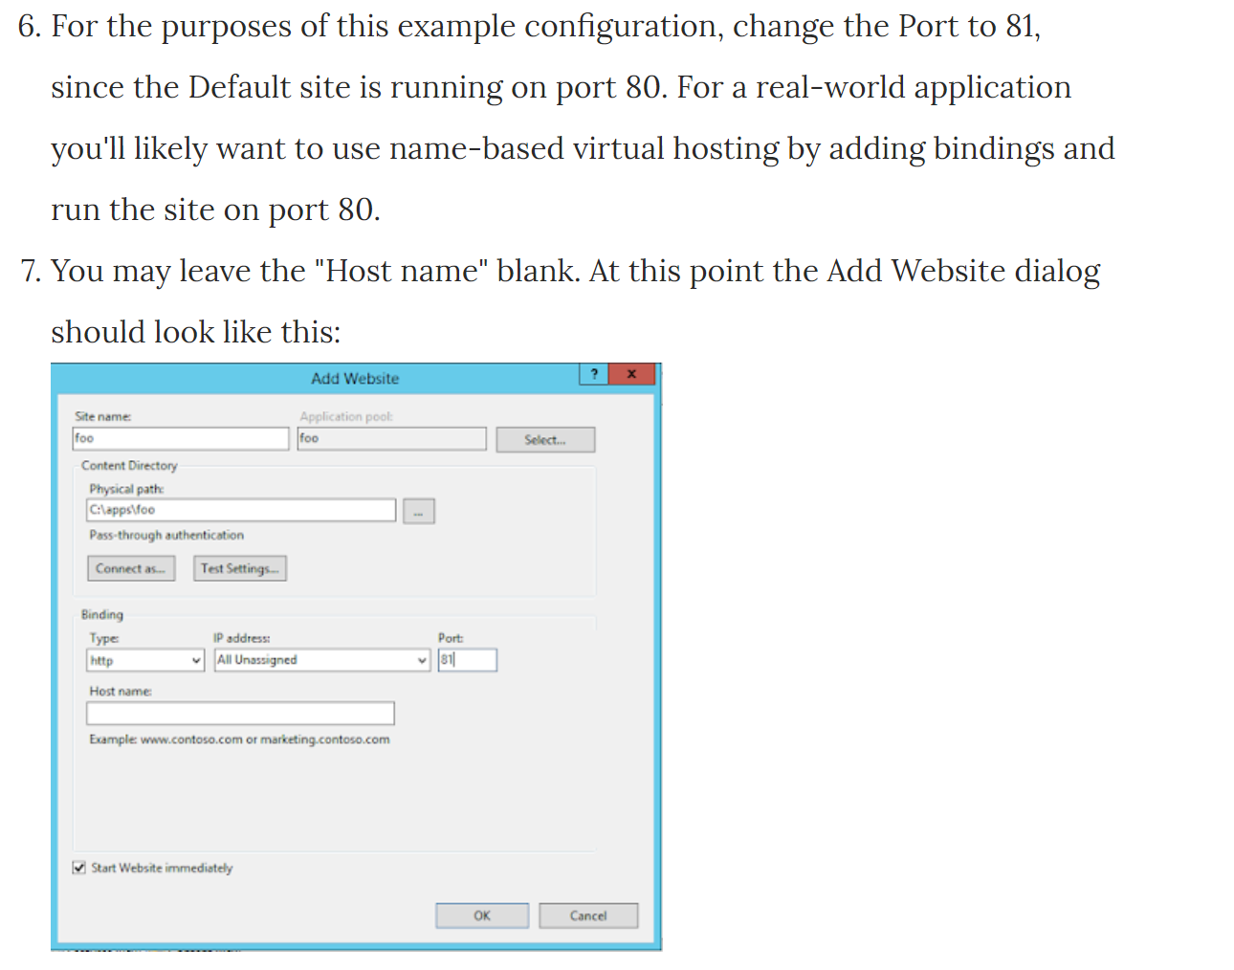

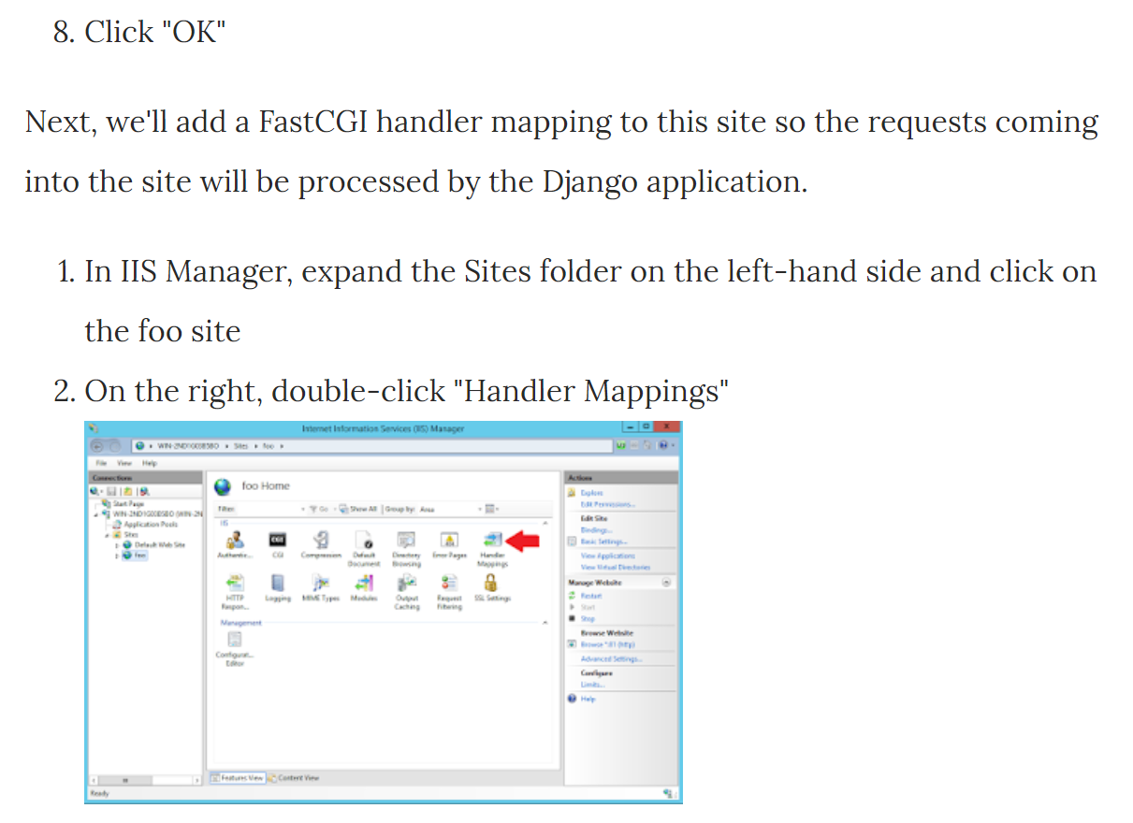

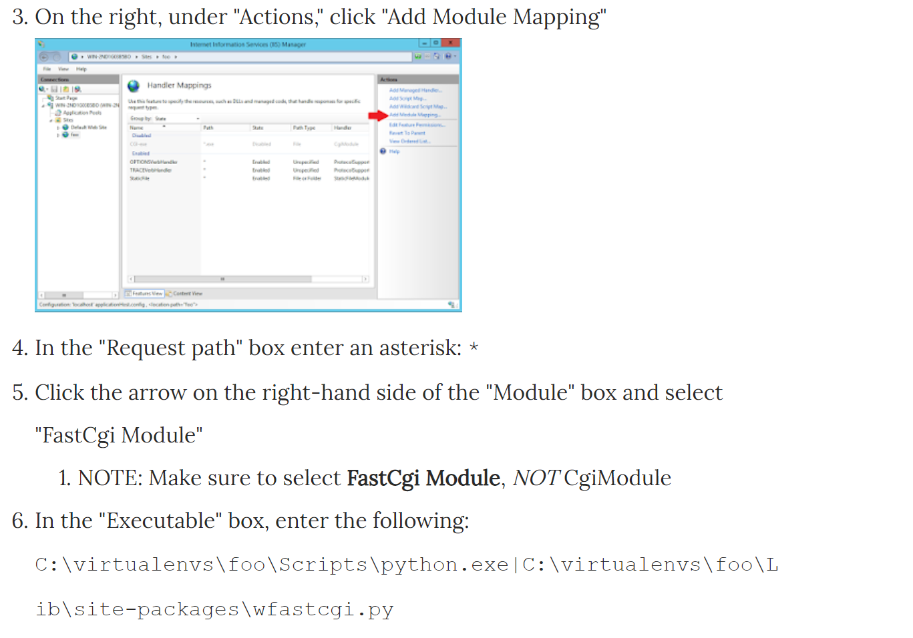

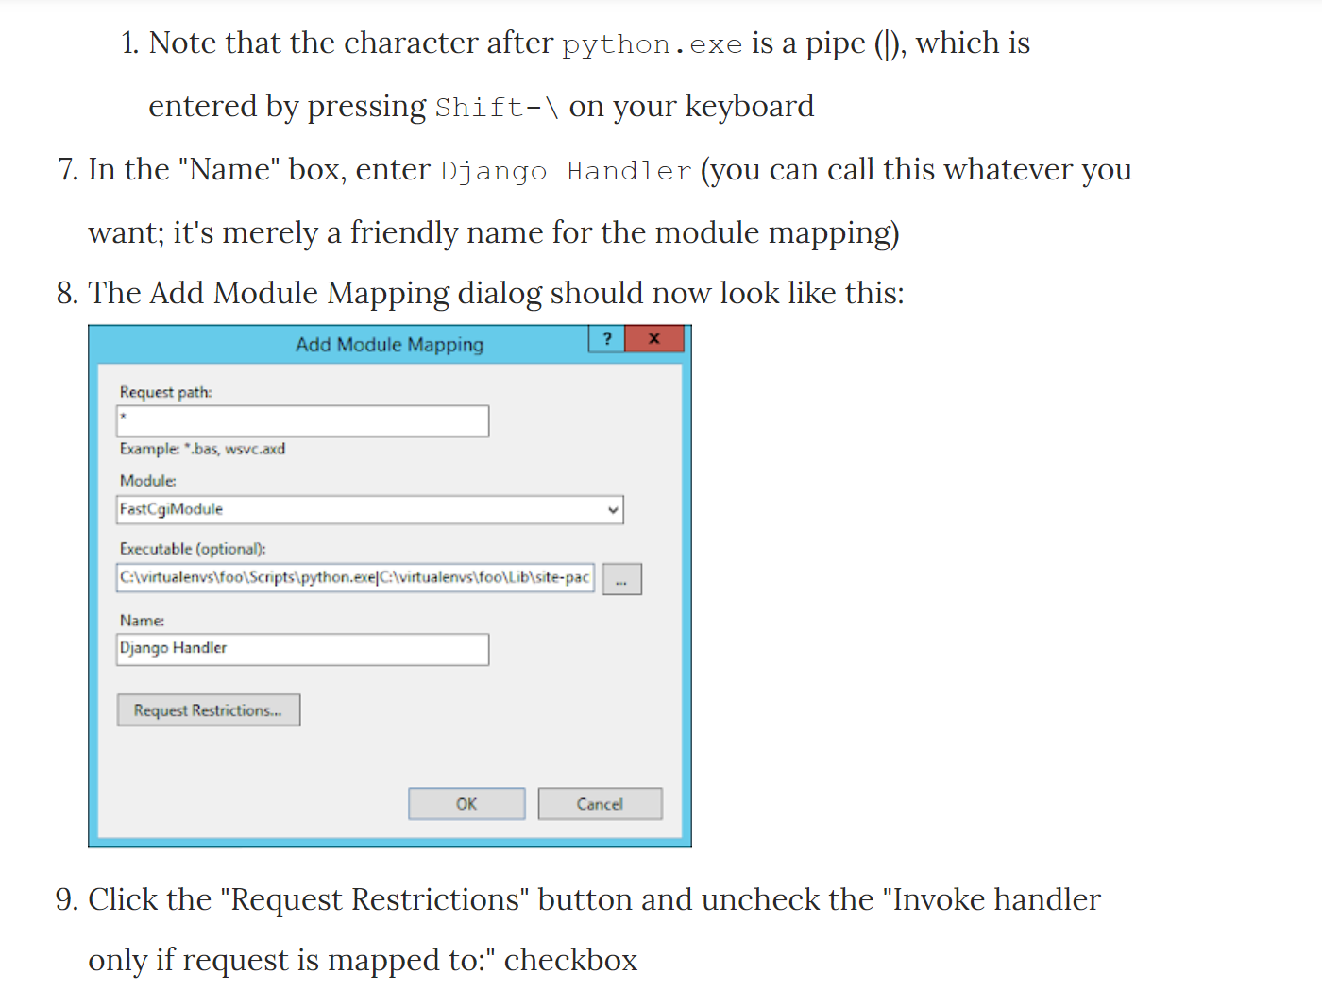

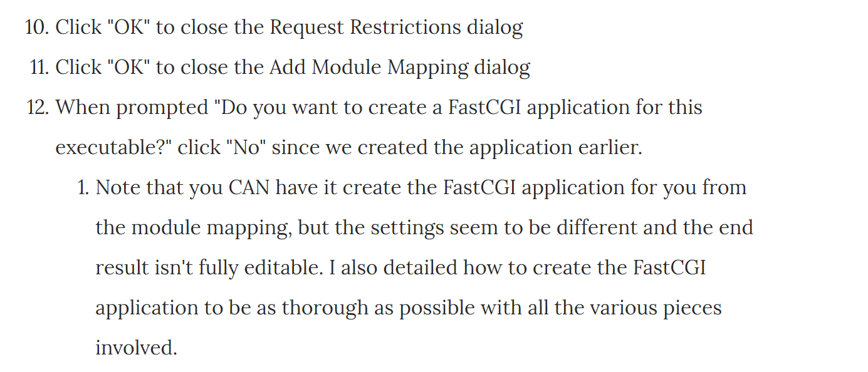

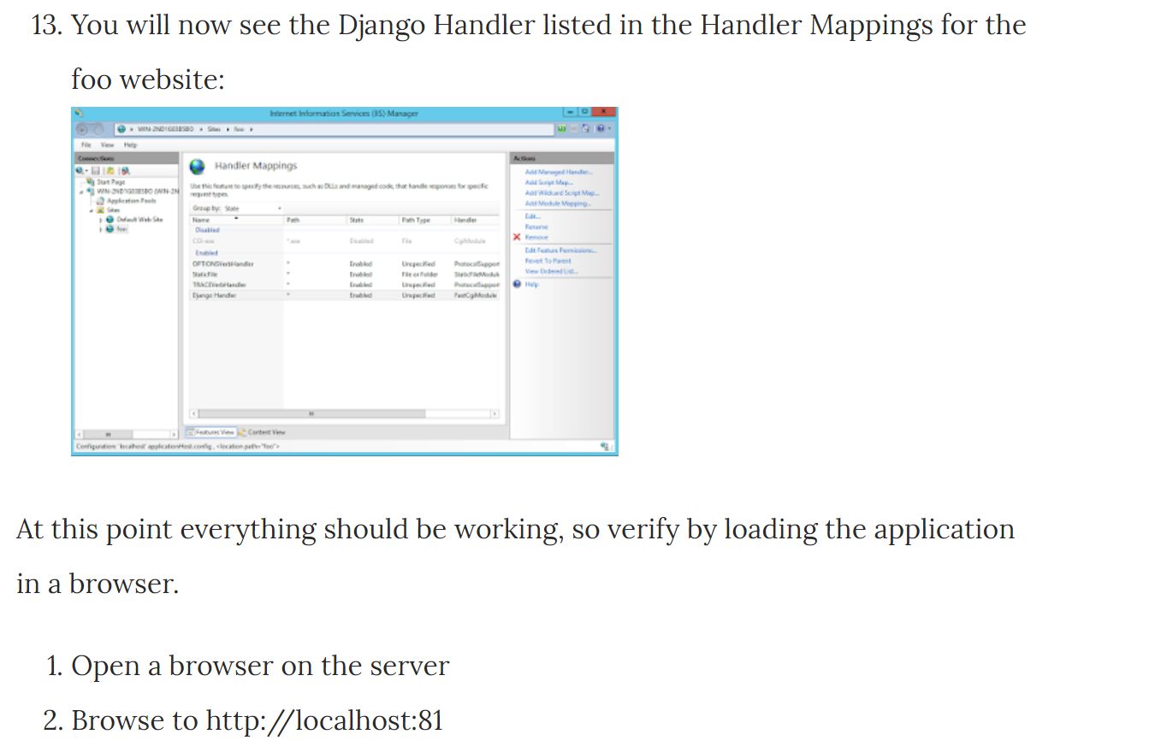

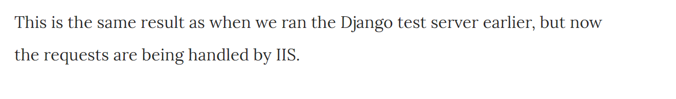

Setup Authentication:

* Enable Window Authentication as I my database is connected though window authentication.